Q1. Imagine you have a remote weather station built with an Arduino. The station has:

* Digital sensors for rain detection (connected to pins 2-4) and wind direction (connected to pins 5-8, each representing a cardinal direction: north, east, south, west).
* Analog sensors for temperature (pin 0) and humidity (pin 1).

You want to log this weather data on your computer for analysis. Here's how the provided code could be used:

1. **Arduino Setup:**
   * The Arduino code would be uploaded to the weather station.
   * The code initializes the digital and analog pins as specified.
2. **Data Acquisition:**
   * The Arduino continuously reads:
     + Rain sensor states (high for rain, low for no rain) on pins 2-4.
     + Wind direction sensor states (each pin representing a direction).
     + Temperature from the analog sensor on pin 0.
     + Humidity from the analog sensor on pin 1.
3. **Data Packing and Transmission:**
   * The code packs the digital sensor data efficiently.
     + It uses bitWrite to set bits in the values integer based on rain sensor states (1 for rain, 0 for no rain) on pins 2-4.
     + Similarly, it sets bits based on the active wind direction sensor (e.g., North sensor active sets a specific bit).
   * The combined digital data (rain and wind) and each analog reading (temperature and humidity) are sent as separate messages using the sendBinary function.
   * The header byte ('H') marks the start of each message.
4. **Data Reception and Logging on Computer:**
   * You'll have a program running on your computer connected to the Arduino via the serial port.
   * This program would be designed to:
     + Identify the start of messages using the header byte.
     + Receive the two bytes of the digital data message and reassemble it into an integer using highByte and lowByte functions (similar to sendBinary).
     + Interpret the individual bits in the digital data to determine rain status and wind direction.
     + Receive the single-byte analog data messages for temperature and humidity.
     + Log the received sensor data (rain, wind, temperature, humidity) with timestamps for further analysis.

Q2.

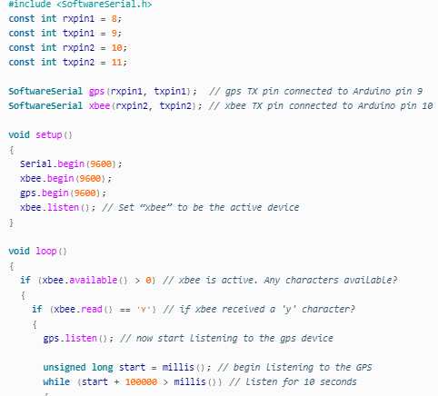

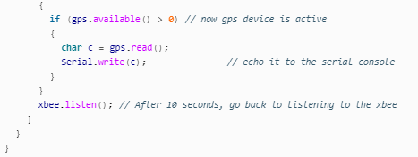

What will be the output? Assume GPS receives the following data in 10 ms.

$GPRMC,081530.00,A,4042.4402,N,7400.0899,W,0.19,339.0,190424,000.0,M,0000,0000*77.